INFS3200 Advanced Database System

Assignment 2

Student Name: Wei-Ting, Hong

Student Number: 47523483

Task 2.

1. In order to separate attributes of raw data into dimension tables appropriately, it should make sense to distribute staff and store information to “staff” table, whereas put PID, BRAND, PRODUCT, UNIT_COST to “product” table. With respect to “time_period” table, the attributes are DATE, year, month, and quarter, just like the statement in task sheet. Corresponding to this design structure, we could create dimension tables by the following SQL.

2_a. By insert information into dimension table from raw data, the terminal return done message with “INSERT 300”. Since SID is a primary key, therefore, we could know there are 300 of employees in total.

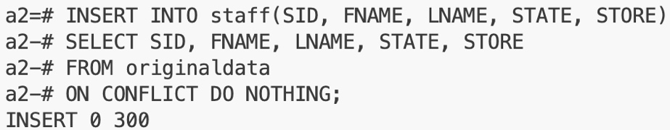

2_b.

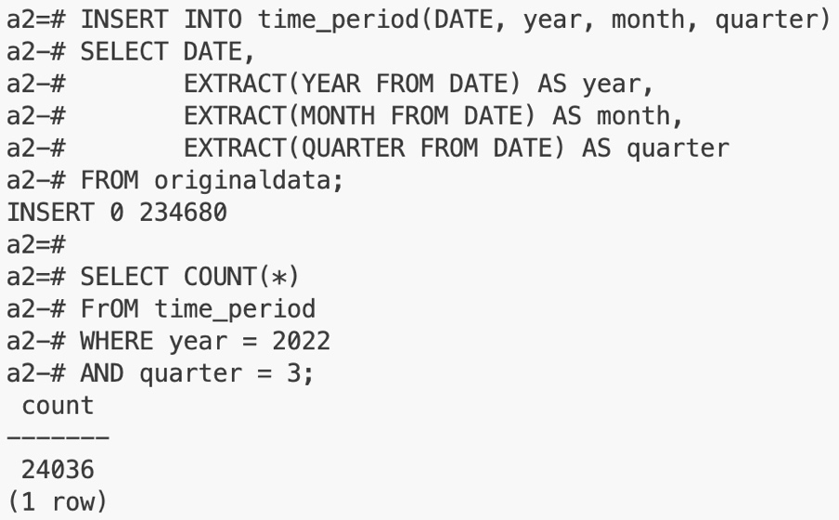

First, we fill up the dimension table related to time by proper SQL. Then do the second SQL to gain the answer specified by task sheet.

3. The following SQL create the specified materialized view. With using sub-query, we could significantly decrease creating time.

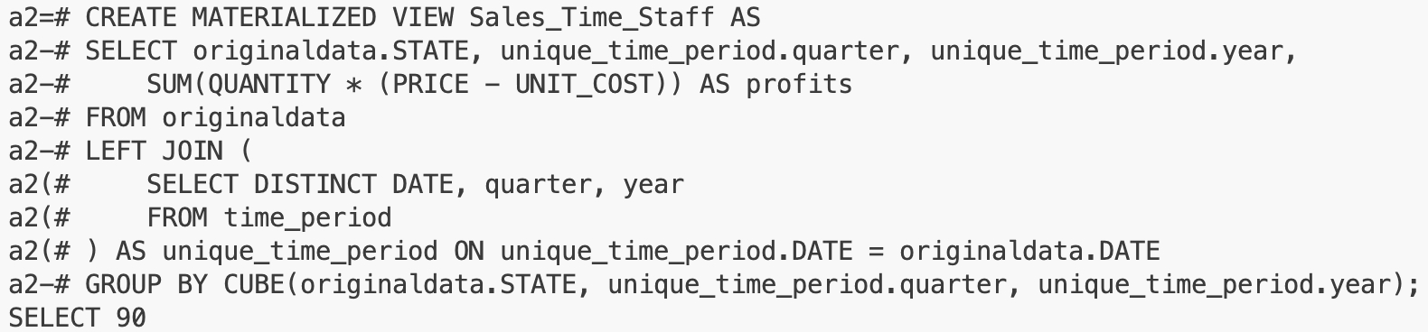

4.

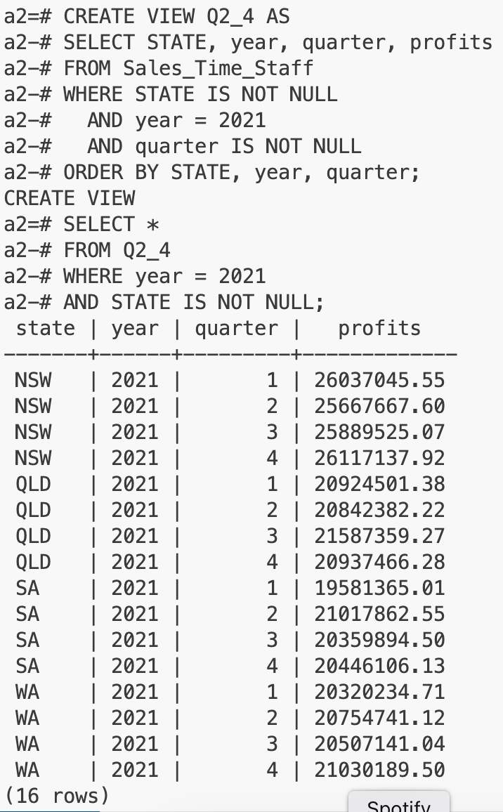

From the SQL above, we can complete the table on task sheet.

The state sales volumes in each quarter of 2021

|  |  |  |  |  |
| --- | --- | --- | --- | --- |
|  | QLD | NSW | WA | SA |
| 2021Q1 | 20924501.38 | 26037045.55 | 20320234.71 | 19581365.01 |
| 2021Q2 | 20842382.22 | 25667667.60 | 20754741.12 | 21017862.55 |
| 2021Q3 | 21587359.27 | 25889525.07 | 20507141.04 | 20359894.50 |
| 2021Q4 | 20937466.28 | 26117137.92 | 21030189.50 | 20446106.13 |

And for the second table:

The state sales volumes in each year.

|  |  |  |  |  |
| --- | --- | --- | --- | --- |
|  | QLD | NSW | WA | SA |
| 2021 | 84291709.15 | 103711376.14 | 82612306.37 | 81405228.19 |
| 2022 | 83071386.73 | 101622087.94 | 85057870.77 | 81780959.56 |
| 2023 | 39502809.73 | 51093461.84 | 41190927.48 | 39806645.50 |

5_a. The SQL of the materialised view “Sales_Product_Staff” should be beloew.

By creating specified view and select all data on it, we could obtain the answer.

